GROWING GOD’S CHURCH – ROOTED IN HIS WORD, RESPONDING TO HIS CALL

I would like to personally thank Bishop David McClay for his leadership in organising these inspiring conferences and also to the Bishop and the members of the Commission on Ministry for their very kind invitation to give the keynote address at this significant occasion for the Church of Ireland.

The right place to start this address ‘Growing God’s Church – Rooted in His word, responding to His call’ is with words of scripture. And what more appropriate than the words of the prophet Isaiah in Chapter 52 from verses 7-10…..
“How beautiful on the mountains are the feet of those who bring good news, who proclaim peace, who bring good tidings, who proclaim salvation, who say to Zion, “your God reigns!” Listen! Your watchmen lift up their voices; together they shout for joy. When the Lord returns to Zion they will see with their own eyes. Burst into songs of joy together, you ruins of Jerusalem, for the Lord has comforted his people, he has redeemed Jerusalem. The Lord will lay bare his holy arm in the sight of all the nations, and all the ends of the earth will see the salvation of our God.”

This is the starting point. As Christians we know our God reigns and Jesus is king. As disciples of Jesus we help in the building of Jesus’s kingdom by lavishly spreading the Good News and living our lives in the way God intended His world to be – a place of beauty and delight.

The Most Revd. Dr. Rowan Williams, formerly Archbishop of Canterbury, said of Alison Morgan’s book ‘The Wild Gospel’, the book is “a groundbreaking, exciting and moving book that could not be more timely as the Church looks for fresh ways of speaking God’s truth in and to our culture”. The book indeed is full of passion about the ways in which the Gospel engages with contemporary life. It splendidly highlights the cultural challenges that have faced all generations since the time of Christ’s ministry on earth and reflects the author’s belief that “absolute truth was God and it became incarnate in His son, Jesus. It made sense of life and the Gospel offered a framework of meaning that could not be shattered by anything”.

Today, just like earlier generations, the secular and human world faces challenges and presents opportunities for the spreading of the Gospel. The geopolitical changes in the world today are causing turmoil in many countries. The international order established after World War Two, 80 years ago, has been wounded and frequently ignored. The globalisation which had been increasing with the interconnectiveness of economies, cultures and populations, driven by rapid trade, technology and capital movement, is now under pressure with the rise of the national protectionism and isolationism. International institutions like the World Trade Organisation and the World Bank which regulate trade and set global policies are acting in conditions of uncertainty.

War and violent conflict prevails in many parts of the globe. The United Nations seems to have lost authority and influence. Social media pervade many aspects of life. Violence against women is a major social and domestic problem and the work of the Mother’s Union in this regard has been highly commendable. Climate change is impacting many landscapes. Wild fires, raging seas, floods and swollen rivers, and intense heat are impacting on different habitats creating life-altering experiences for those caught in their wake. Recent years have seen much cultural change in our society and the world at large. Professor Jeffrey Arnett of Clark University, Mass., in the United States has undertaken extensive research in what he refers to as an emerging adulthood. Fifty years ago young male adults, on leaving school, went into work while girls became wives and mothers. Today, though 18-29 year olds still explore relationships and look for work, it is taking longer to find permanent jobs and establish permanent personal relationships. In contrast to 50 years ago, giving birth to babies happens later and fewer babies are being born. Mothers used to be aged in their early 20s when they first had children but now, as with marriage, they are older, usually in their late 20s or 30s. Today, in the period from 18-29, young adults are still exploring who they are. Some struggle with this and can experience anxiety and concern, even leading to mental health issues. Social medial makes the answer to the question ‘Who am I?’ harder, constantly presenting images and identities that are a challenge for young adults to navigate, and often difficult to accept.

Migration into Europe has led to large number of people arriving on our shores, some trafficked, looking to make a home, to find work, to escape political persecution or repression. As we know, a sense of unease is emerging among the national indigenous populations and, since that could impact on electoral outcomes, governments are tightening regulation and legislation.

The National Convention on Education in the South of Ireland has begun its’ deliberations. Its’ Chair, Professor Anne Looney of Dublin City University, has spoken of the importance of maintaining social connections for families and children and society in general. There is a real need to create places where people can meet in safety and share company and interests. This view concurs with other commentary. Social capital, defined as the network of relationships, the trust and shared norms that enable individuals and groups to collaborate effectively and achieve common goals, badly needs to be strengthened. We need to encourage shared understanding that will help communities and organisations function more effectively, according to Heifer Britannica.

The rise and fall of New Atheism has been charted by Justin Brierley, the broadcaster and writer, host of The Unbelievables show and podcast. Brierley recounts the 2009 UK Atheist Bus campaign slogan ‘There’s probably no God’, and the Reason Rally in the US in 2012. Today Justin Brierley, however, says New Atheism is largely a spent force. It has faded from public view as a serious cultural phenomenon, and he adds ‘a new breed of secular thinkers are considering the value of Christianity and its’ social and community wellbeing and benefits’. Those considering and enquiring about faith are both asking big questions around the meaning of life and Christian truth and seeking a community where they feel they truly belong. This fresh interest in the Christian faith has come as a surprise to many. They had become resigned to the fact that the Church as they knew it was declining and its’ influence waning. It is not uncommon in the Church of Ireland to find members assuming that attendance at church services is the sure barometer of the strength of a Parish. Indeed, counting the numbers is often a task for the churchwarden and attendance is recorded in the Service Book after every service. Informally I suspect counting the congregation can also be a pastime for the members of the congregation when their attention is not fixed on the sermon! Clergy too may believe church attendance is a barometer of the effectiveness of their ministry in the Parish and then they feel discouraged by low attendance and small numbers. Societal norms in relation to going to church have changed greatly. Respectability, which once led people to attend church, is no longer a factor. Today the words of scripture from the 3rd Chapter of St. John’s Gospel ring a bell when Jesus said “the wind blows wherever it pleases, you hear the sound”. So a crucial question is this: What sounds are new enquirers hearing from the Church?

A number of recent reports in Ireland and elsewhere have shown particularly, but not exclusively, that a cohort of young adults between 18-30 are actively seeking a life of faith, and attending church, in the search for meaning in their lives and membership of a community.

The Praxis Report in 2024 explored the opinions and perspectives of young adults in Ireland about issues of faith and life with specific questions about church, mission and climate change. The Report found that 99% of those interviewed saw the importance of creating community. 96% saw the importance of strengthening faith and enabling people to encounter God, to be essential and important activities in the Church. Almost 66% of those interviewed aged between 22-26 had a good experience of church. 58% read their Bible daily and 63% prayed every day.

You may have seen and heard of the increase in the sale of bibles. Bible sales are an example of a global trend of renewed engagement with scripture driven by social uncertainty and personal spiritual exploration. People are seeking hope, guidance and meaning through the printed word and the bible. The Guardian newspaper has written about the increase in bible sales since 2019 and 2025. Over that period there has been an increase of 106% bringing in revenue of £6.3million. The bibles have been largely bought by younger people exploring Christianity. The Amity Printing Co. in China is printing 70 bibles every minute. In Ireland, through the National Bible Society, 29,755 bibles were bought in 2025, an 11% increase over 2024.Growth in access to the Bible through apps is being reported by YouVersion, the company who’s free apps have been downloaded on more than 1 billion devices. It reported in early April 2026 that an average of 18.7 million people had accessed one of its apps on each day of Holy Week. The number rose to 21.6 million on Easter day – the highest number in the company’s history. The most popular verse was Matthew 28.6 “He is not here, he has risen, just as he said. Come and see the place where he lay”. Worldwide Bible engagement through the apps through Holy week worldwide grew 15% on last year.

Justin Brierley recalls the story of the French writer and intellectual Voltaire, who reputedly predicted that 100 years from his day there would not be a bible on earth except as a curiosity from times past. The great irony of Voltaire’s prediction is that, 100 years after he made it, his own home in Geneva, Switzerland had become a storehouse for bibles and tracts produced by the Evangelical Society of Geneva. In fact, contrary to Voltaire, the bible today remains the best selling, most published book in the world - bar none.

Another interesting development is the increase of people participating in Alpha courses. Alpha explores the basics of the Christian faith in a friendly, open and informed environment. Alpha began in 1977 in Holy Trinity Church, Brompton, a Church of England parish in London. Over the last half century Alpha has grown and continues to grow. Between 2022 and 2025 the number of Alpha youth courses grew by 100%. In Mullingar, Alpha started some years ago and over 200 young people participated every year. Overall, a third of those who participate in Alpha are under 25 years of age. In 2024, 250,000 young people in 53 countries participated in hearing the gospel in their ‘heart language’, making access to faith easier.

Youth workers in the Church of Ireland are encouraged by what they are seeing. Over 6,000 young people are part of Parish Youth Ministry. Last year just under 3,200 young people, their leaders and volunteers attended Summer Madness, a music and faith festival organised by Summer Madness. The number already signed up for this year’s Summer Madness is even higher than it was at this time last year in 2025. The Church of Ireland Youth Department has highlighted other encouraging signs of interest among young people in their Strategic Plan. 25% of Parishes have a link with their local Secondary School and last year, in 2025, over 4,000 teenagers visited the Church of Ireland tent at the National Ploughing Championships in Tullamore. The Select Vestry in Mullingar some years ago engaged an academic researcher to undertake a Parish survey. As part of the Report “God Matters” the researcher spent time on the children’s survey. The report found that 76% of children like going to church, 68% of youth felt faith was important and 74% believe prayer was also important. The findings of this report went on to birth two significant initiatives in the Parish, Lighten Our Darkness and the Alpha course. The benefit of both is now being seen in the lives of the children and youth who have now become young adults. In the Republic of Ireland 30,000 every day attend National Schools under Church of Ireland management. What a rich opportunity for parishes to engage with these children on their faith development.

A further Report has come out this year in Ireland is The Turning Tide. It reveals that younger people are showing a new interest in religion and spirituality, and that there is a modest revival in faith, especially among young adults. Ireland remains one of the most religious countries in Europe and the report shows that there is an up-tick in interest among 16-29 year-olds. 51% of Irish adults pray weekly, 27% of Irish young adults pray weekly, and often this prayer is offered in centres that are not traditional or conventional. The Church of Ireland National Director of Vocations has recently said regarding vocations that “there are positive trends, with an increase in the numbers of those called to ministry in the age bracket of 20s-50s and the annual vocation retreat held earlier this year had an encouraging number of participants”.

The Iona Institute has also carried out research and found that 18-24 year-olds are the most likely of any group to hold a very positive view of Christianity, even more than those over 65. The same survey showed that young people today are more likely to pray and engage with religious content than those just slightly older than them, suggesting a generational shift. Importantly, this trend is not isolated – the survey notes that the patterns being observed in Ireland are also found in Britain and the United States. Overall, the Iona Institute report concludes that religion is not disappearing as once predicted. Instead it seems to be re-emerging in a new and more polarised form among younger generations. Premier Christian Radio broadcasts Christian programs across the UK. It was first aired in 1995. By 2014 its’ weekly reach to listeners had grown to 240,700 and by 2024 it had a weekly reach of 1.1 million listeners. In every Diocese in the Church of Ireland there are small and large initiatives creatively connecting with people. The Pioneer Ministry which exists in addition to traditional Parish ministry is offering a renewed focus for the Church to connect in fresh ways with those who have lost, or have never had any, connection with the Church. This initiative is fully endorsed by the House of Bishops and will be rooted in each Diocese. Pioneer Ministry hubs have been established and events and projects are being launched across the Church of Ireland. These findings seem to be reflected in the latest statistics for global Christianity 2025. There are currently over 2.6 billion Christians in the world and this number is growing by 0.98% each year, making Christianity the largest world religion representing 33% of the global population. In Africa last year it was recorded that there were more than 750 million Christians and also the number of Christians in Asia is also growing.

The reports and initiatives I have referred to, and the findings I have mentioned, highlight a growing interest in God, Jesus, Church and religion, particularly among young adults and this, I hope, you will find very encouraging. The Revd. Dr. David Goodhew, Vicar of St. Barnabas Church in Middlesborough, and visiting Fellow of St. John’s College, Durham University, has recently said “I think we need some scepticism about ecclesial doomsters”. He warned against decline theology which assumes the inevitable decline of the Church. Such thinking, he says, has no basis in the New Testament or in the Christian tradition.

On Easter Day 1804, at St. Paul’s Cathedral in London, just 5 people received Holy Communion. Two centuries years later St. Paul’s reported that 400,000 people attended church services in the course of 2024, and the Cathedral welcomed 1.4 million visitors as a vital part of its’ mission. When Psalm 90 says “for a thousand years in your sight are but as yesterday” it should serve as a reminder that God takes the long view, and so should we. God’s thoughts are not our thoughts and our little bit of history is never the whole story.

I would like to invite you to take a moment now for a prayerful thought and reflection on these findings as we listen to part of the inspiring hymn ‘The goodness of God’.

Douglas Murray, the associate editor of The Spectator, has written about the crucial part Christianity played in establishing the cultural and moral bedrock of Britain. He challenged the leadership of the Church to focus its’ preaching and practice on teaching the Gospels.

Tom Wright, the esteemed biblical theologian, reminds us that God’s wonderful News is acting in and through Jesus to turn the world upside down, or the right way up.

I asked our 10 year-old granddaughter to draw me a picture of what the world would look like the ‘right way up’. This is what she drew.
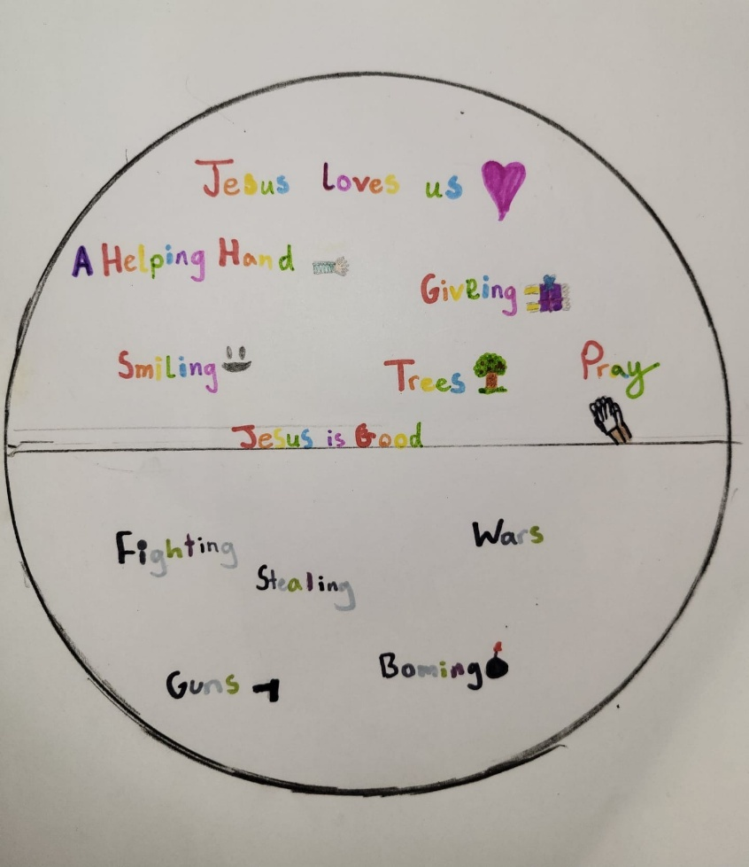

She, in her innocence, sees the world as God see it through divine eyes. She sees God’s will.

We can spend so much of our time trying to make sense of God and the world by looking at the world ‘upside down’. God has clearly annunciated His will, and we find it in scripture. The bible helps us to see the world the ‘right way up’. God’s will emerges in Nicodemus’s conversation with Jesus. Nicodemus has seen God’s will in the ministry of Jesus and clearly knows that Jesus comes from God. But Jesus makes it clear to Nicodemus that no one can really see God’s divine kingdom unless they are born again. Christ has come from God to birth heaven on earth. Jesus makes that clear in the Lord’s prayer “Thy will be done on earth as in heaven”. That is the excitement of God’s wonderful Good News. We only see the world the ‘right way up’ when we accept the divine grace through Jesus who comes from heaven. Spending energy appeasing and persuading earthly institutions and structures and ologies and isms doesn’t work. Through the Cross, Jesus disarmed these powers. The only thing that works and matters is accepting God’s will from heaven.

In the world which is the ‘right way up’ God’s energy creates goodness through His love for us and the world he has created. We receive this love and can show this love through the power of the risen Lord Jesus. When we live by grace we find God’s love has the power to conquer all. God’s way is the power of love, not the love of power that is sadly so evident today in the geopolitical world. The power of love is transformative and overcomes the love of power, what Ephesians 6 describes as “the powers of this dark world and against the spiritual forces of evil. Therefore stand firm with the belt of truth buckled around your waist, with the breastplate of righteousness in place.” Ephesians 6, verses 12 and 14

On hearing Jesus’s invitation to follow Him, the first disciples “at once they left their nets and followed Him” (Matthew 4, verses 18-22).

Henry Longfellow in his poem confidently wrote
Then pealed the bells more loud and deep:
“God is not dead, nor doth He sleep;
the Wrong shall fail,
the Right prevail,
with peace on earth, good-will to all.”

As a Church we hear the peal of the bells….
The bell of those enquiring
The bell of those searching
The bell of those seeking
The bell of those suffering

The right does prevail, so the Church has wonderful news to bring and share. So, like the first disciples, will we “at once leave and take on the Christian witness”?

I asked our 13 year-old grandson to create an image of a faith-bearer. A lovely phrase Tom Wright uses. He created a fish,

why, because fish can swim anywhere, bringing a message. God’s message moves through the landscape of grace – God’s creation and the words of Jesus, like a fine artist, paint an inspiring backdrop for our Christian witness. We are called to become faith-bearers.

Jesus says “The wind blows wherever it pleases” (John 3, verse 8). Fulfilling the will of God in service, like the wind, is not confined. God’s work is on a broad canvas and God calls people to different and various vocations. The Parish is but one vehicle of His grace, albeit an important one. So, the fish swims in many seas to enable us to establish God’s kingdom where Jesus is King.

As faith-bearers we are called to first prioritise God and Jesus. This is inspiringly illustrated in the ministry of one of the perhaps lesser-known leaders in the bible. Haggai in the Old Testament, was a prophet. When the ancient people return from exile after 70 years in Babylon under the rule of king Nebuchadnezer, Haggai’s faith priority came into prominence. He found that the people were engaging in what Gerard Ford referred to as the “me generation”. Their first priority was to build homes for themselves but Haggai challenged them with these words “Is it a time for you yourselves to be living in your panelled houses, while God’s house remains a ruin?” (1 v 4). Haggai reminded the people of the importance of reordering their priorities. Through Haggai’s witness the people responded. The House of the Lord was built and the Lord Almighty declared “The glory of this present house will be greater than the glory of the former house” says the Lord Almighty “and in this place I will grant peace” declares the Lord Almighty (2 v 9). Haggai assured the people that God will bless them.

Our priority must first be God and Jesus, as the writer to the Hebrews makes it abundantly clear when he wrote “fix your eyes on Jesus, the pioneer and perfecter of faith”. (Hebrews 12 v 2)

As faith-bearers, we must prioritise the place of the Bible. The bible is essential to Christians. It is the inspired authoritative word of God, the primary guide for faith, for life and for understanding God’s character. It reveals the story of salvation through Jesus Christ our Lord.

As faith-bearers our churches are centres of grace where welcome and biblical hospitality is inspiringly evident. Biblical hospitality is fundamentally important to Christians because it is a direct command from God, a reflection of the Gospel and a way to show Christ’s life and love to the world, by opening ourselves, our churches, our homes to others, building communities that demonstrate God’s grace.

As faith-bearers we must be true worshippers. Jesus reminds us “God is spirit and His worshippers must worship in the spirit and in truth”. These are the kind of worshippers the Father seeks. (John 4, verses 23-24). Prayer and worship are vital to Christians as the primary ways of building a personal relationship with God, receiving spiritual strength and expressing gratitude and adoration. Prayer and worship foster a deeper connection to God’s love and will. They provide peace, enabling us to align our lives with Christ’s teaching. Our church worship is happily on a continuum, offering both contemporary and formal ways to worship God through the Bible, our prayers and our music.

As faith-bearers we embrace the Great Commission of Jesus (Matthew Chapter 28, verses 16-20)
Then the eleven disciples went to Galilee, to the mountain where Jesus had told them to go. When they saw him, they worshipped him; but some doubted. Then Jesus came to them and said, “All authority in heaven and on earth has been given to me. Therefore go and make disciples of all nations, baptizing them in the name of the father and of the Son and of the Holy Spirit, and teaching them to obey everything I have commanded you. And surely I am with you always, to the very end of the age.”

As faith-bearers our task is to go and make disciples of all nations, teaching them to obey everything that Jesus has taught us. This involves spreading the Good News of Christ, and identifying those areas in life where Christ’s compassion is urgently needed. Those are the places where we, as faith-bearers, can be the feet and hands of our loving Saviour. During World War 2, Archbishop William Temple was Archbishop of Canterbury. He reminded the Church that “the Church is the only society that exists for the benefit of those who are not its’ members”. The Methodist Church in Ireland benefitted from the ministry of one of its’ most inspiring ministers, Revd. Sydney Callaghan. It was said of him that when he was stationed in a Methodist church, the church was the base from which he worked, not at which he worked. These two Christ-inspired Christians remind us of how important it is that we go out with confidence to share the Good News. All too frequently Christians gather in their churches simply waiting for people to come to them. But we must go out to make the connection. It is essential that we not only hear the words of Christ’s commission: we must act upon it.

Many high-profile stars of screen and stage have publicly embraced Christianity, citing it as a source of transformation, peace and purpose. Two notable artists who have publicly spoken of their Christian faith are Sir David Suchet and Talia Dean. Sir David Suchet, famous for playing the part of Poirot, is a committed Christian who converted at the age of 40 after reading Romans 8 in a hotel while filming in Los Angeles. As a Christian he has a total faith in Jesus and he cites the importance of John’s Gospel and the writing of St. Paul in his spiritual journey. Faith is the most important thing in his life and this love of scripture has had a profound impact on him. Talia Dean is a professional singer based in London and was a finalist in the X Factor ITV show. In a conversation with Sean Fletcher on BBC Songs of Praise she spoke about how for years she was never satisfied, no matter how much she had. If 500 people turned up to a concert she wondered why it wasn’t 1,000. After Christmas Day 2023, having spent a few years feeling emotionally very low and searching for something, she found that after Christmas she was especially stressed. She returned to the church where she had been brought as a child and found the doors were locked. She sat in the churchyard with her head in her hands, begging for some sign of warmth and love. She came across it through the kindness of three women who appeared in the churchyard – the Vicar’s wife and two daughters. They invited Talia to their home for tea and after the hospitality they asked if they could pray for her. During the time of prayer Talia felt the whole room lit up. The entire kitchen was alight. That evening Talia, in her own home, said to the Lord “I just need one sign and I will give you everything”. It was grey and raining outside. Suddenly the clouds parted and the sun came into her room just as it had done in the kitchen. “I felt loved”. It was a life-changing experience with Jesus and Talia now spends her life as a worship singer and wrote the song of thanksgiving “I will praise your name”. The biblical hospitality she received in the churchyard was a changing point in her life. Talia wants other people to follow the faith she has found in Jesus as she believes it will bring joy to their soul as it has done to hers.

Bells have historically served as crucial audible signals, loud enough to be heard. Bells were introduced to Christianity some 400 years after the Resurrection of Jesus. Our churches, in chiming the right tune, provide us all with the opportunity to communicate the Good News and to donate our time to ministry in the sacred spaces where our church is located.

In familiar words Genesis Chapter 1, verse 31 says “God saw all that He had made and it was very good”. Human frailty has broken that goodness in so many ways - in the care of people and in the care of creation. Yet we are forever blessed that God sent His son Jesus to be the healer of the brokenness and to bring restoration and hope. What a privilege it is to have the opportunity to be inspired in our witness by Jesus, our Saviour and our Friend.

So, with new signs of hope all around to encourage us, rooted in God’s word and responding to God’s call, let us together grow His church. In the words of the hymn by Graham Kenedrick, let us work to see again the beauty of God’s love replacing the brokenness of humanity and the hope of Christ replacing the world’s despair.

END

